|  |
| --- |
| **LAPORAN PRAKTIKUM JARINGAN KOMPUTER**  **2.3.7**  **PACKET TRACER – NAVIGATE THE IOS** |
|  |
| **Agus Pranata Marpaung**  **13323033**  **DIII TEKNOLOGI KOMPUTER** |
| **INSTITUT TEKNOLOGI DEL**  **FAKULTAS VOKASI** |

**Judul Praktikum**

|  |  |  |
| --- | --- | --- |
| **Minggu/Sesi** | : | I/3 |
| **Kode Mata Kuliah** | : | 1032101 |
| **Nama Mata Kuliah** | : | JARINGAN KOMPUTER |
| **Setoran** | : | Jawaban dalam bentuk *softcopy* |
| **Batas Waktu Setoran** | : | *Sesi Praktikum Selanjutnya* |
| **Tujuan** | : | 1. Mahasiswa dapat mengidentifikasi komponen pada jaringan komputer dan juga dapat melakukan konfigurasi sederhana terhadap switch dan end device dengan menggunakan simulator Packet Tracer. |

**Petunjuk**



**Packet Tracer - Navigate the IOS**

# Objectives

**Part 1: Establish Basic Connections, Access the CLI, and Explore Help**

**Part 2: Explore EXEC Modes**

**Part 3: Set the Clock**

# Background / Scenario

In this activity, you will practice skills necessary for navigating the Cisco IOS, such as different user access modes, various configuration modes, and common commands used on a regular basis. You will also practice accessing the context-sensitive Help by configuring the **clock** command.

# Instructions Part 1: Establish Basic Connections, Access the CLI, and Explore Help

**Step 1: Connect PC1 to S1 using a console cable.**

1. Click the **Connections** icon (the one that looks like a lightning bolt) in the lower left corner of the Packet Tracer window.

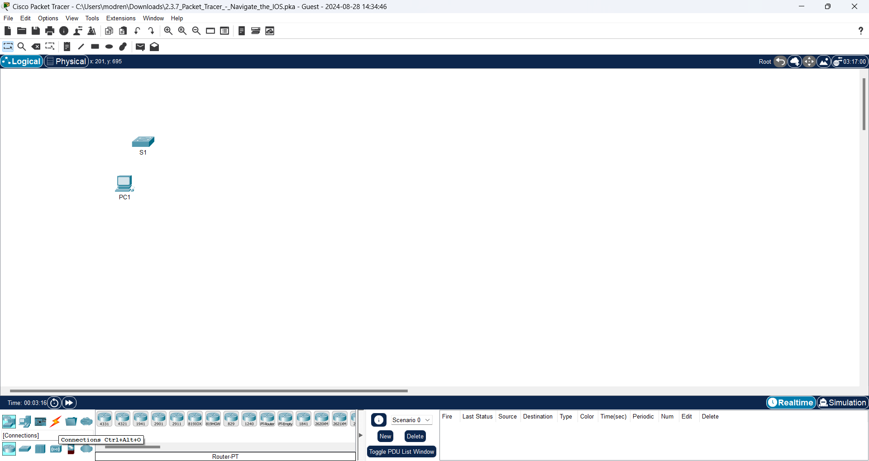

1. Select the light blue Console cable by clicking it. The mouse pointer will change to what appears to be a connector with a cable dangling from it.

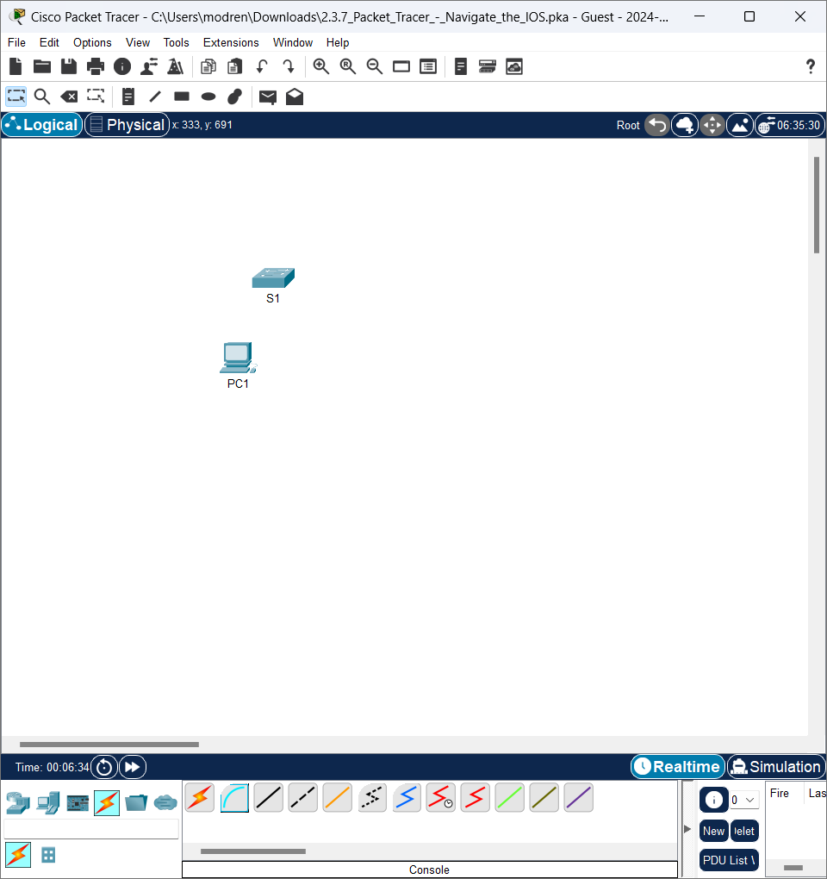

1. Click **PC1**. A window displays an option for an RS-232 connection. Connect the cable to the RS-232 port.

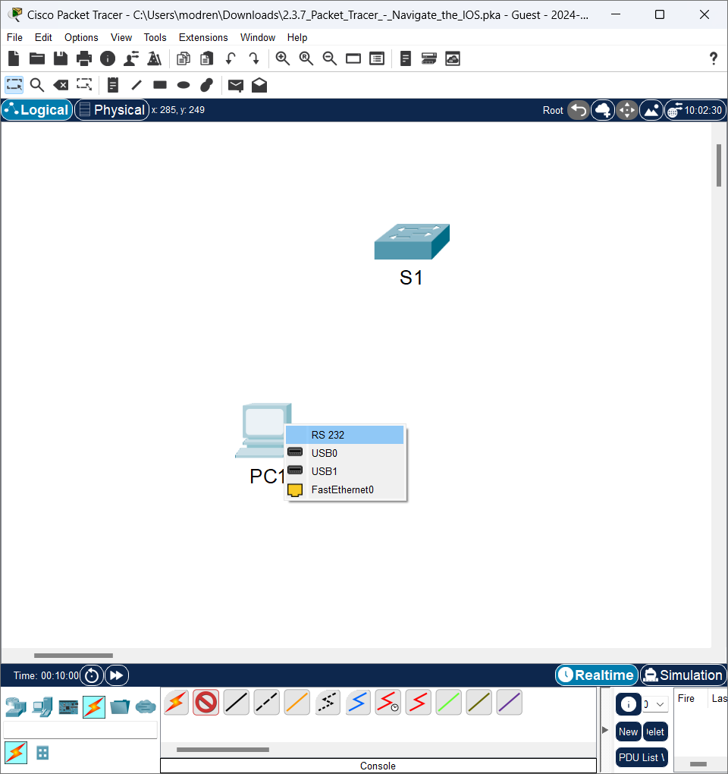

1. Drag the other end of the console connection to the S1 switch and click the switch to access the connection list.

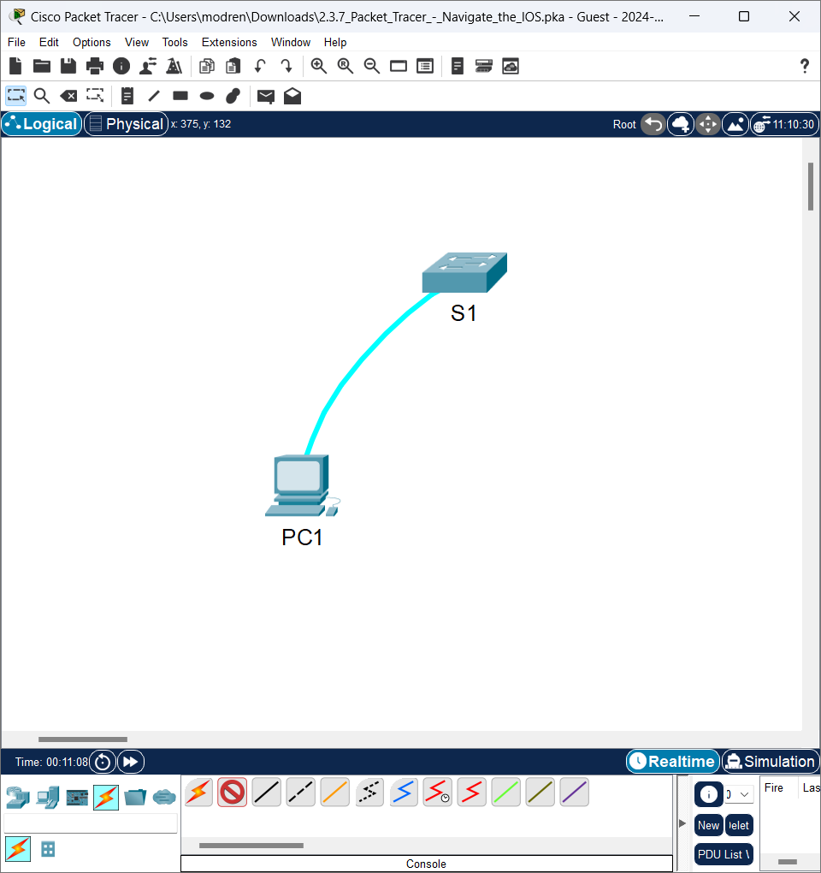

1. Select the **Console** port to complete the connection.

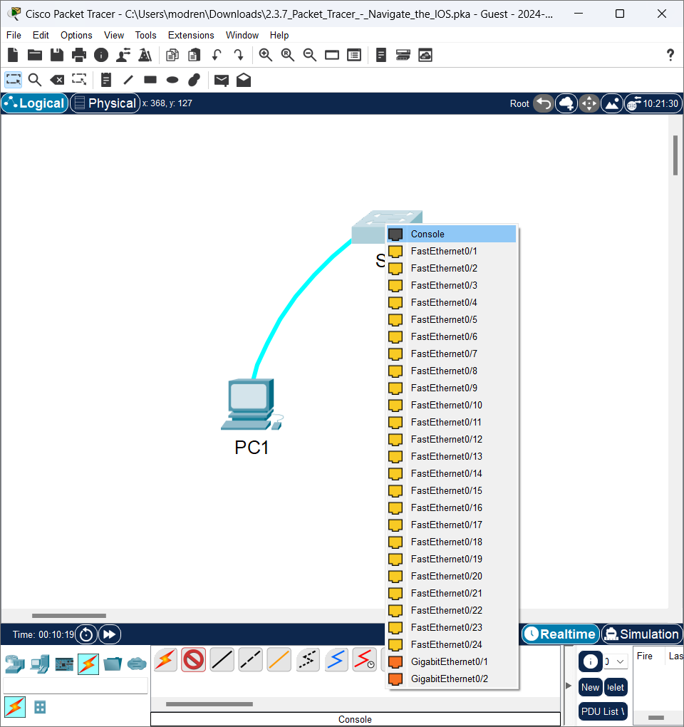

**Step 2: Establish a terminal session with S1.**

1. Click **PC1** and then select the **Desktop** tab.

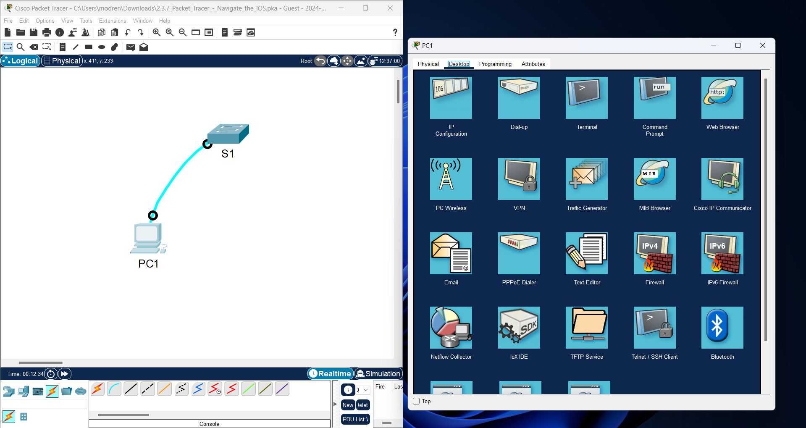

1. Click the **Terminal** application icon. Verify that the Port Configuration default settings are correct.

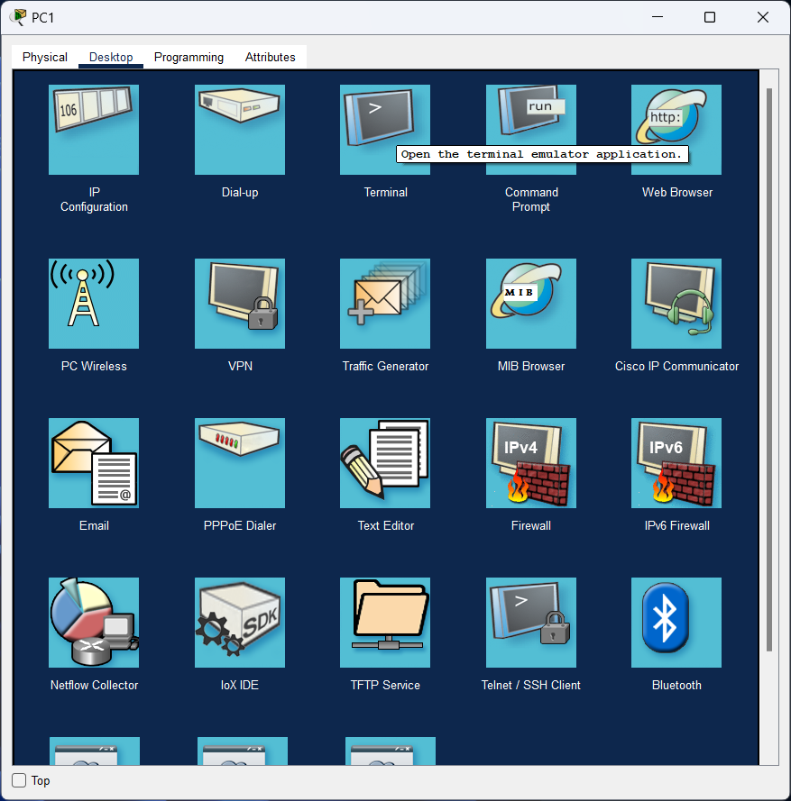

Question:

What is the setting for bits per second?

**Answer:**

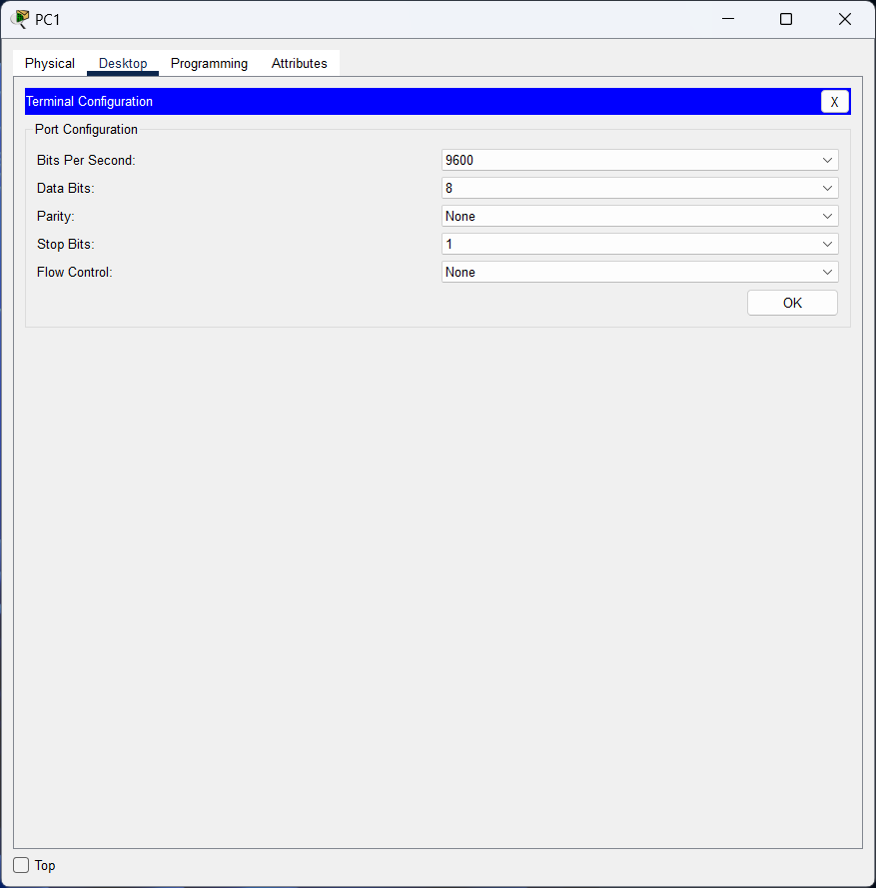

Bits Per Second : 9600

1. Click **OK**.



1. The screen that appears may have several messages displayed. Somewhere on the screen there should be a **Press RETURN to get started!** message. Press ENTER.

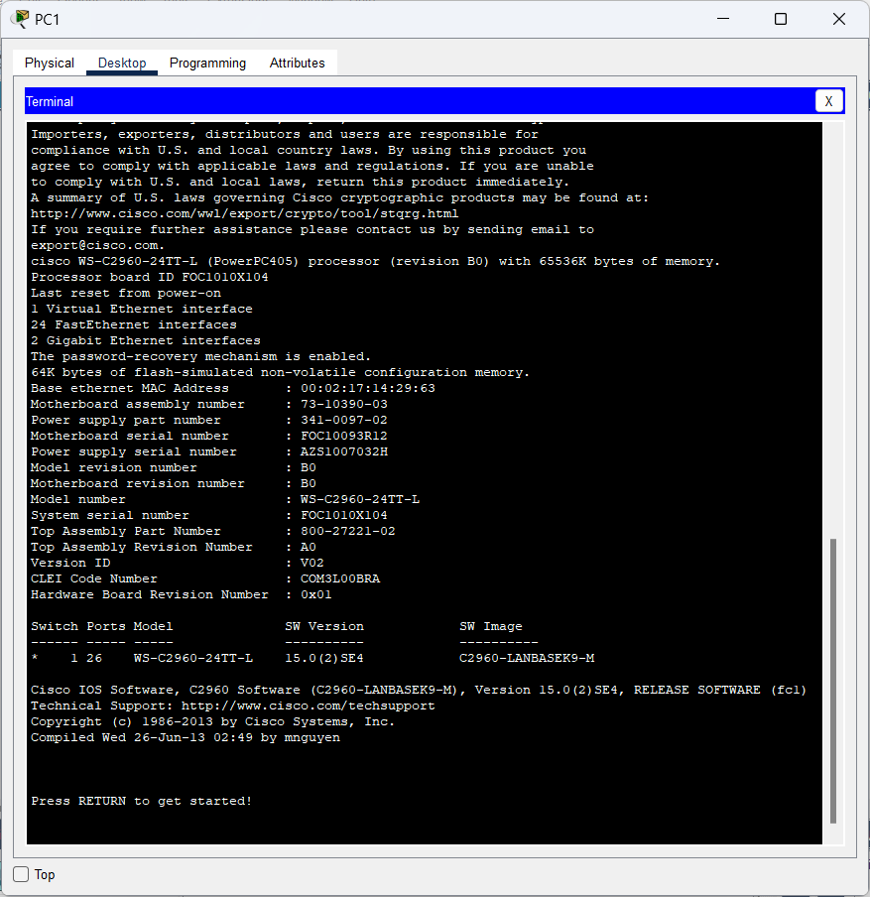

What is the prompt displayed on the screen?

**Answer:**

The prompt displays some detailed info on the network specifications of the PC and a list of those connected to the switch.

**Step 3: Explore the IOS Help.**

1. The IOS can provide help for commands depending on the level accessed. The prompt currently displayed is called **User EXEC**, and the device is waiting for a command. The most basic form of help is to type a question mark (?) at the prompt to display a list of commands.

S1> **?**

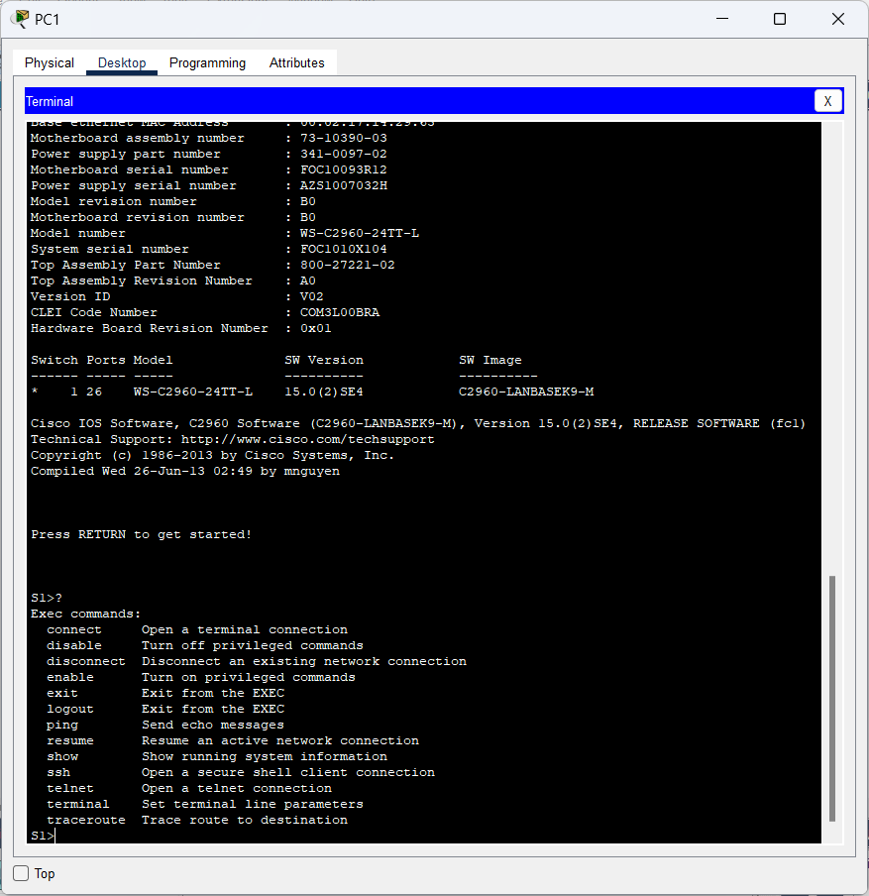

Which command begins with the letter ‘C’?

**Answer:**

The command that starts with the letter 'C' is “connect”

1. At the prompt, type t and then a question mark (?).

S1> **t?**

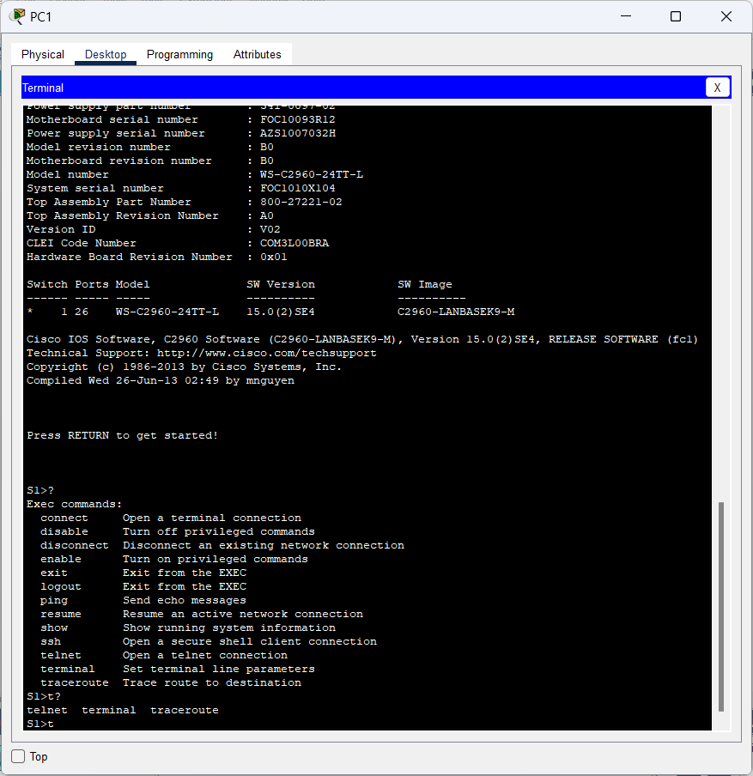

Which commands are displayed?

**Answer:**

The commands shown in the image are **telnet**, **terminal**, and **traceroute.**

At the prompt, type te and then a question mark (?).

S1> **te?**

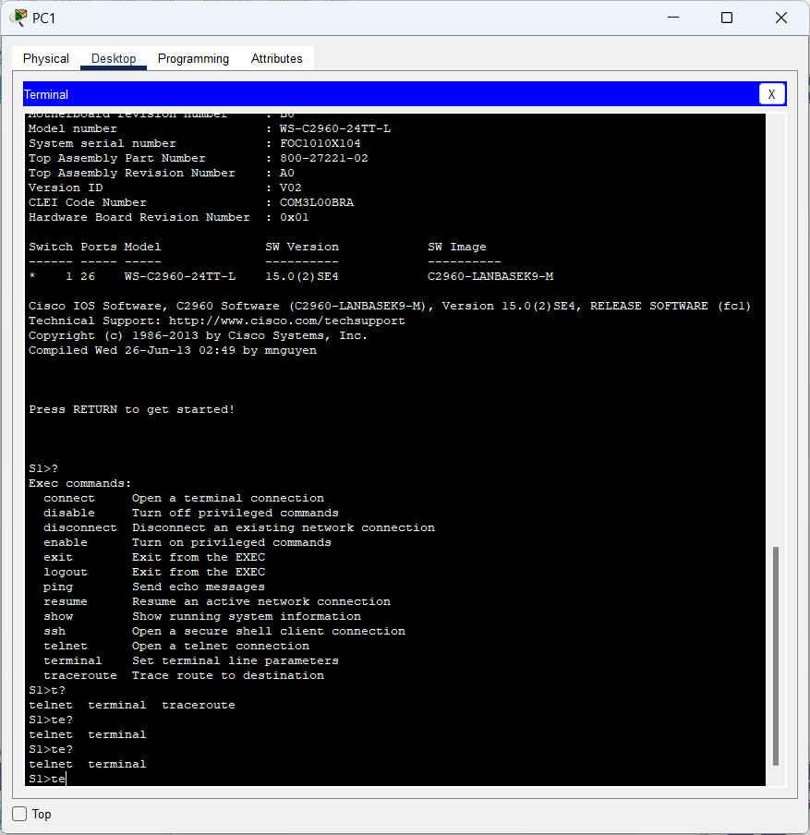

Which commands are displayed?

**Answer:**

The commands shown in the image are **telnet**, and **terminal.**

This type of help is known as context-sensitive help. It provides more information as the commands are expanded.

# Part 2: Explore EXEC Modes

In Part 2 of this activity, you will switch to privileged EXEC mode and issue additional commands **Step 1: Enter privileged EXEC mode.**

1. At the prompt, type the question mark (**?**).

S1> **?**

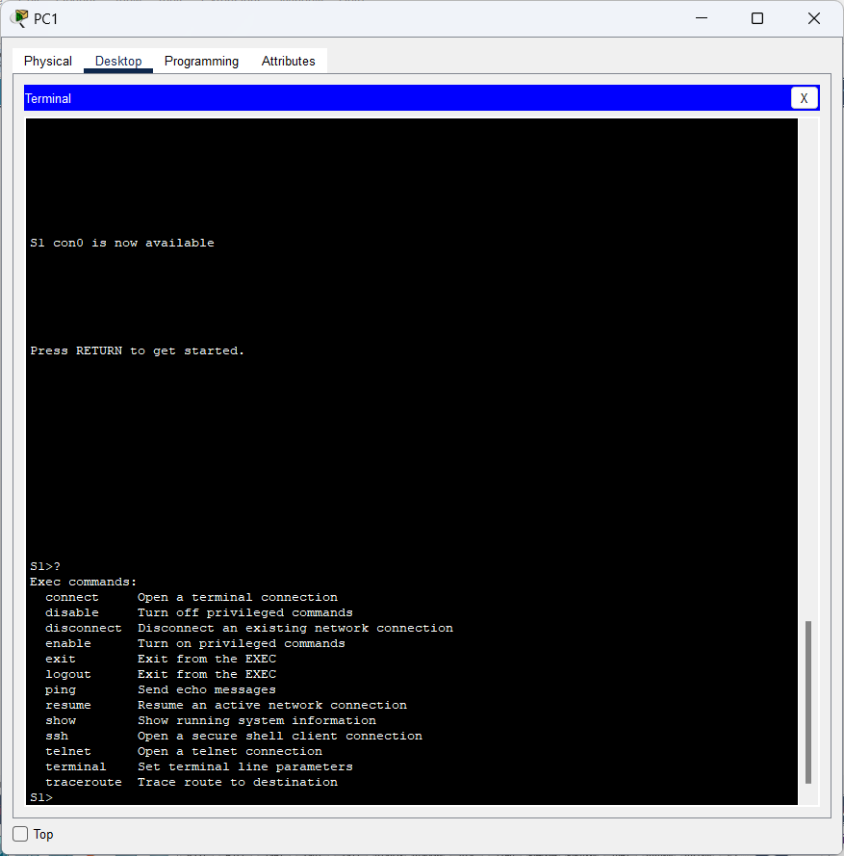

What information is displayed for the **enable** command?

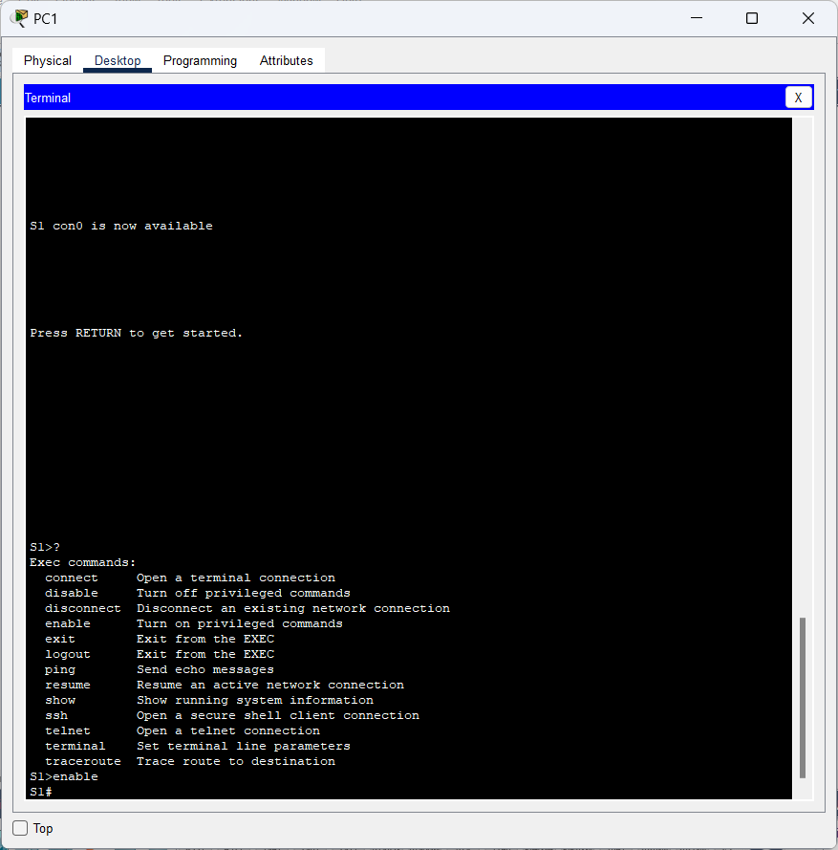

**Answer:**

The command displayed after executing the enable command is S1#.

1. Type **en** and press the **Tab** key.

S1> **en<Tab>**

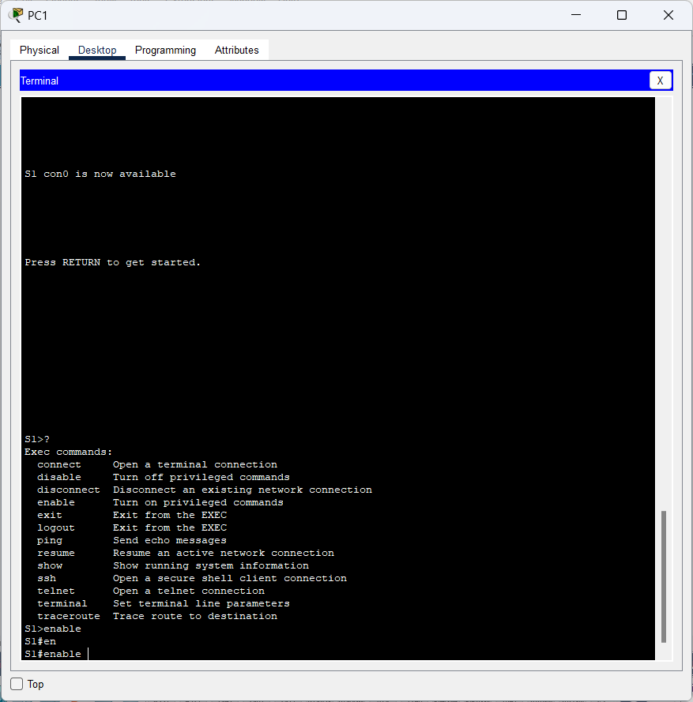

What displays after pressing the **Tab** key?

**Answer:**

The command displayed after typing en and pressing tab on the keyboard displays the **S1#enable** command.

This is called command completion (or tab completion). When part of a command is typed, the **Tab** key can be used to complete the partial command. If the characters typed are enough to make the command unique, as in the case of the **enable** command, the remaining portion of the command is displayed.

What would happen if you typed **te<Tab>** at the prompt?

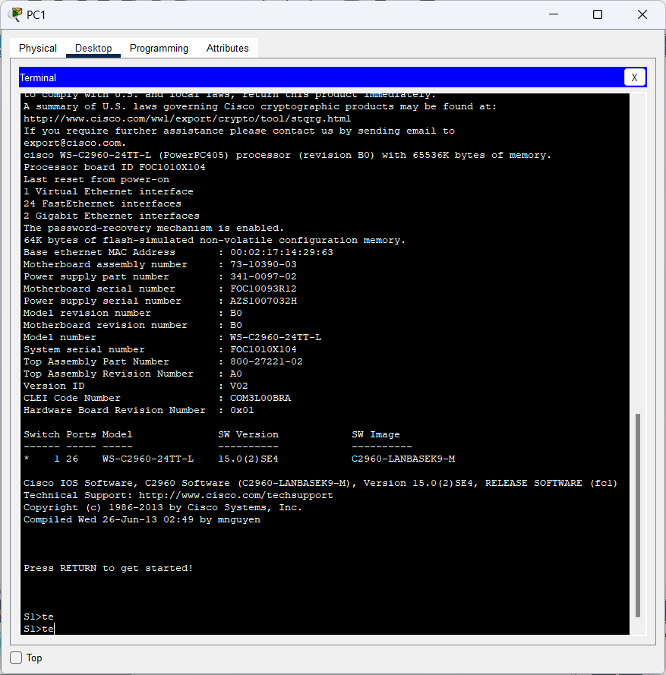

**Answer:**

The command displayed when typing te and pressing the tab key on the keyboard will copy the previously typed command.

1. Enter the **enable** command and press ENTER.

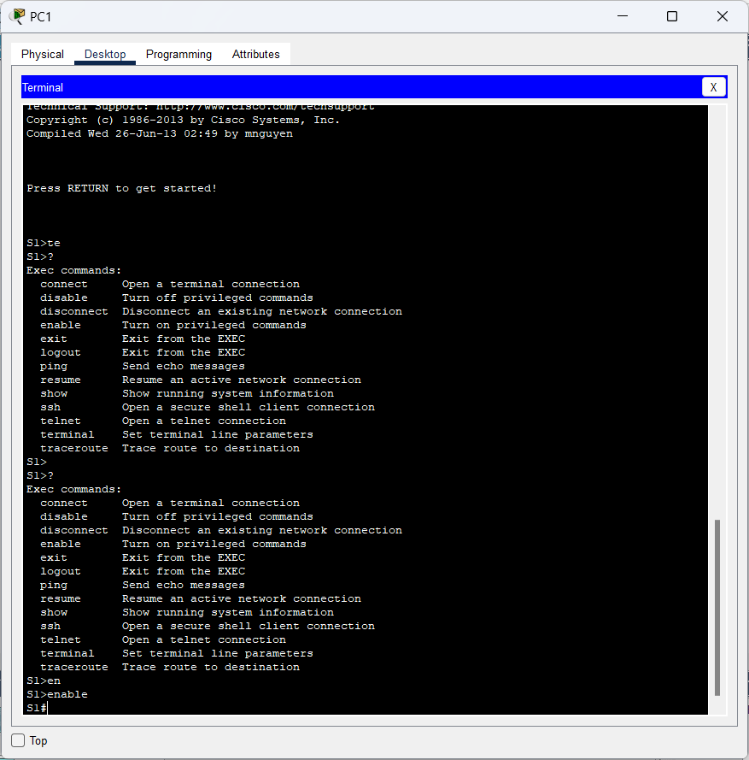

How does the prompt change?

**Answer:**

The prompt change in the above image is the same as the prompt when entering EXEC mode at number 1.

1. When prompted, type the question mark (**?**).

S1# **?**

One command starts with the letter ‘C’ in user EXEC mode.

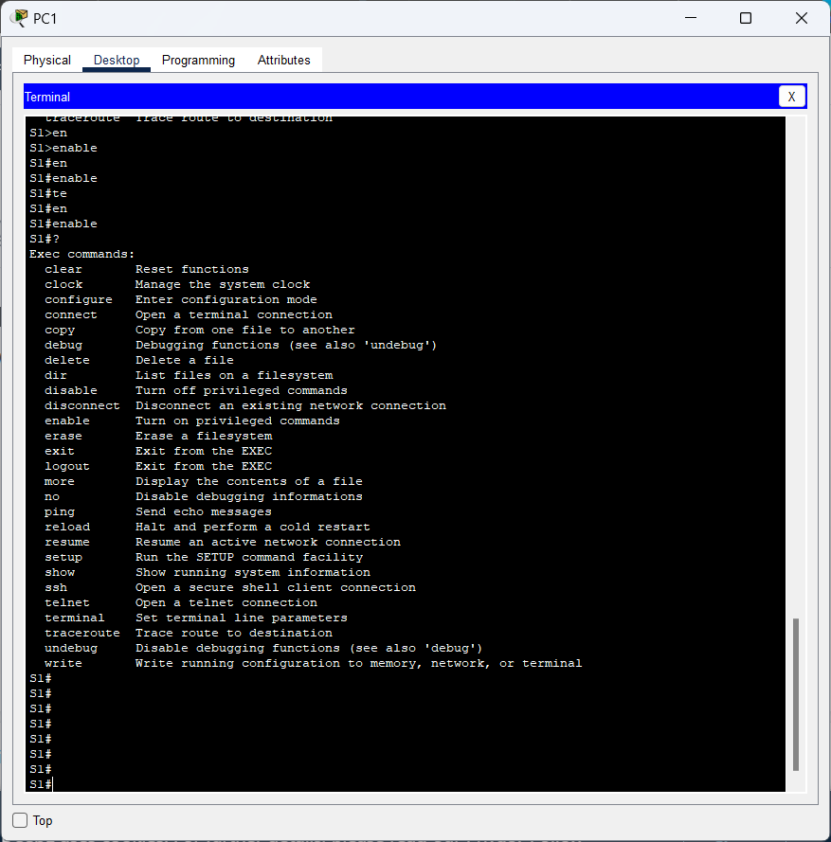

**Answer:**

The output of the executed command is to display a list of executable commands.

How many commands are displayed now that privileged EXEC mode is active? (**Hint**: you could type c? to list just the commands beginning with ‘C’.)

**Answer:**

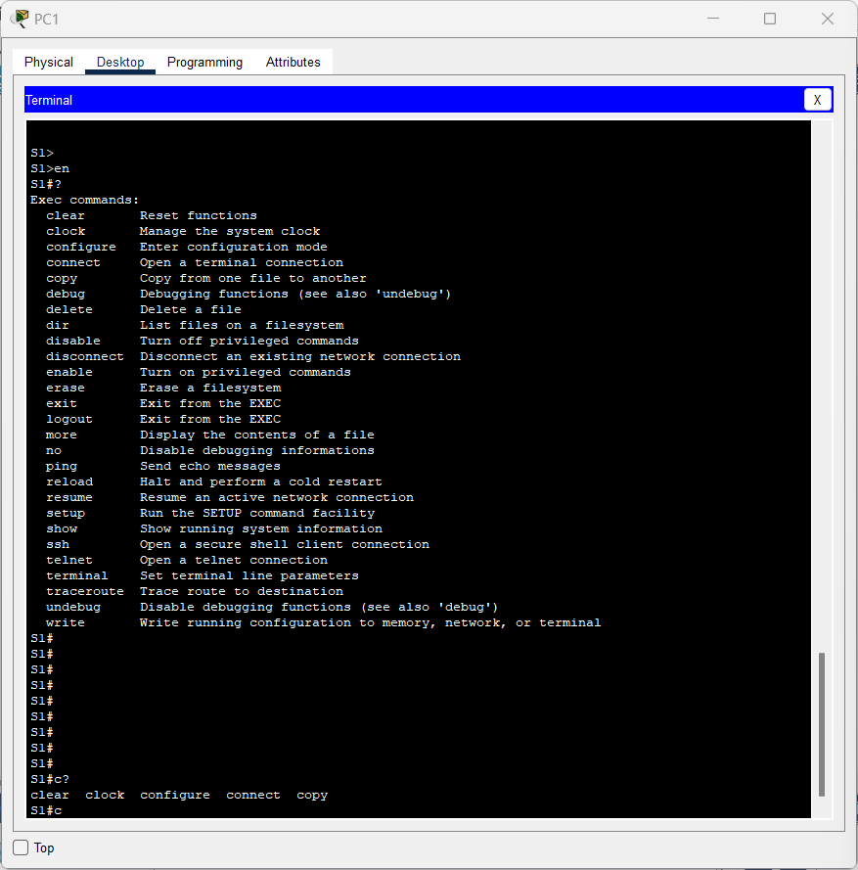

The commands that appear when I search for the prefix letter C are **clear**, **clock**, **configure**, **connect** and **copy.**

**Step 2: Enter Global Configuration mode**

1. When in privileged EXEC mode, one of the commands starting with the letter ‘C’ is **configure**. Type either the full command or enough of the command to make it unique. Press the <**Tab**> key to issue the command and press ENTER.

S1# **configure**

What is the message that is displayed?

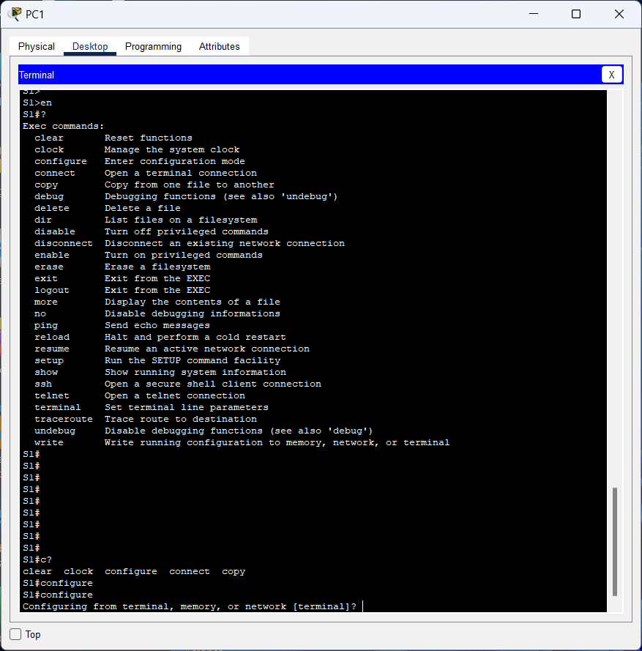

**Answer:**

The command displayed when running the configure command, displays questions to configure the terminal, memory, or network but the terminal is automatically selected.

1. Press Enter to accept the default parameter that is enclosed in brackets **[terminal]**.

How does the prompt change?

**Answer:**

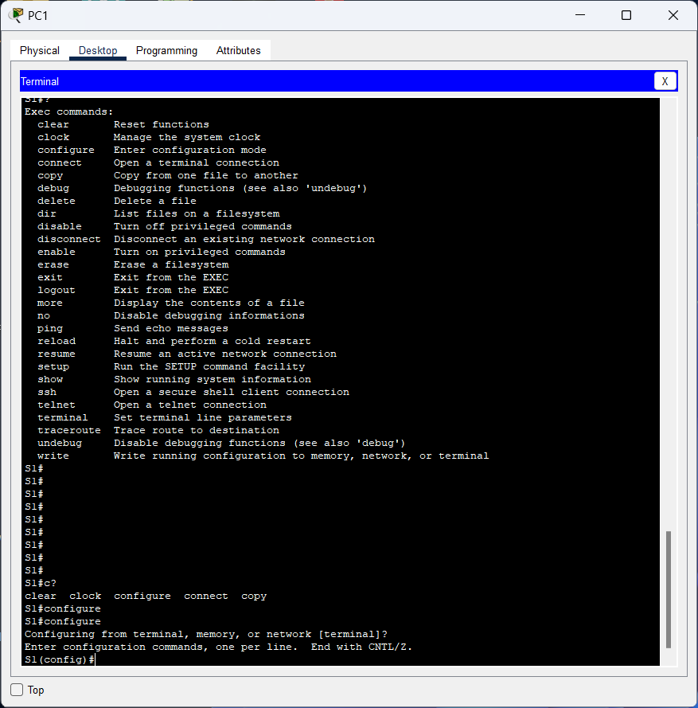

**Answer:**

The output of the executed command configures the terminal, memory, or network and the auto-selected option is terminal and pressing Enter configures the command one line at a time.

1. This is called global configuration mode. This mode will be explored further in upcoming activities and labs. For now, return to privileged EXEC mode by typing **end**, **exit**, or **Ctrl-Z**.

S1(config)# **exit**

S1#

**Answer:**

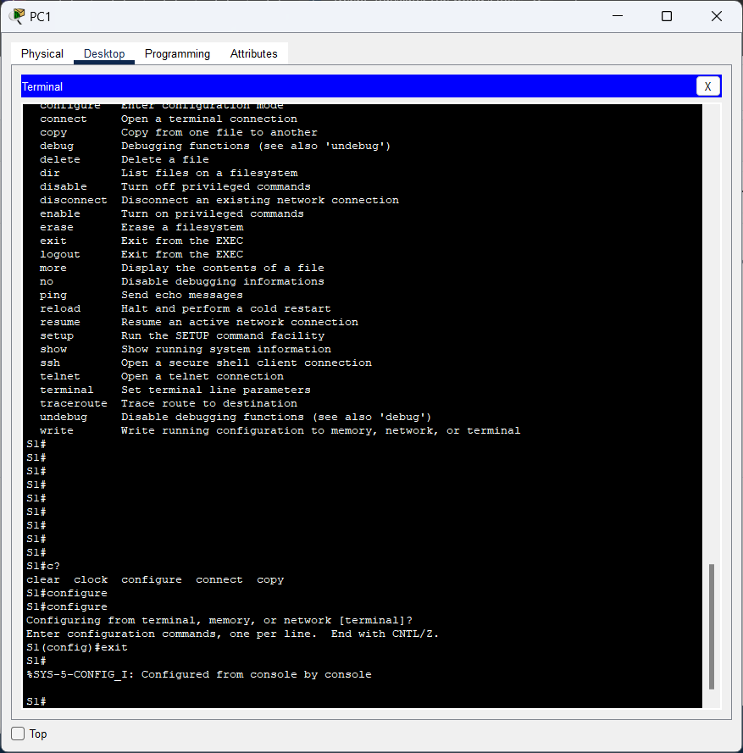

**Answer:**

The command in the picture above is the display when you have run the exit command and can also the end command or press the keyboard shortcut ctrl-z.

# Part 3: Set the Clock

**Step 1: Use the clock command.**

1. Use the **clock** command to further explore Help and command syntax. Type **show** **clock** at the privileged EXEC prompt.

S1# **show clock**

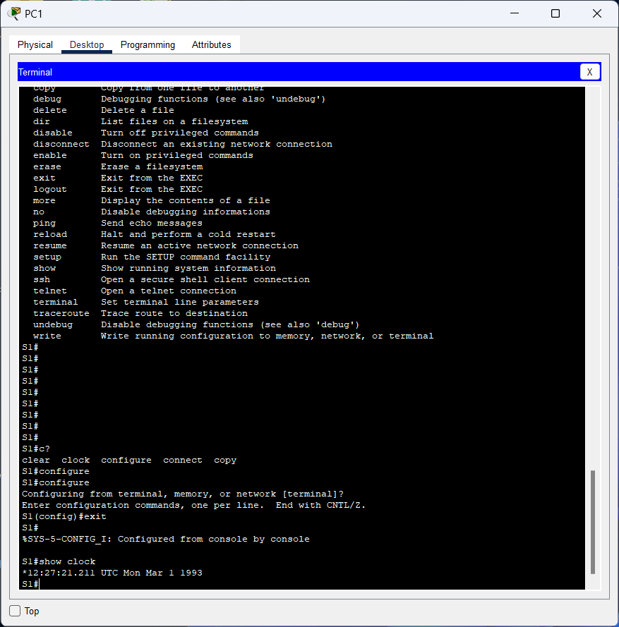

What information is displayed? What is the year that is displayed?

**Answer:**

The commands displayed when running the show clock command are hour, minute, second, millisecond, time zone, day, month, date, and year. The year displayed in the command is 1993.

1. Use the context-sensitive help and the **clock** command to set the time on the switch to the current time. Enter the command **clock** and press ENTER.

S1# **clock<ENTER>**

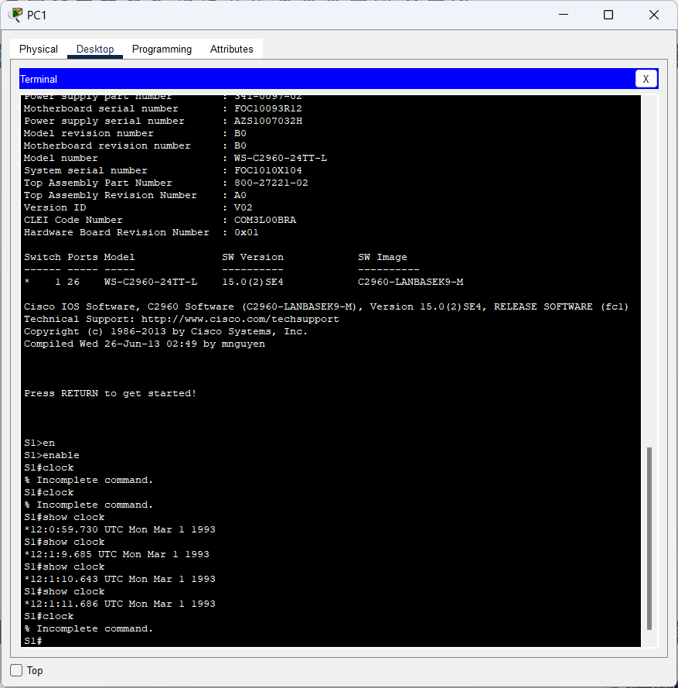

What information is displayed?

**Answer:**

The output of the executed command is a command that cannot be completed, which means that the executed command cannot be executed.

1. The “% Incomplete command” message is returned by the IOS. This indicates that the **clock** command needs more parameters. Any time more information is needed, help can be provided by typing a space after the command and the question mark (?).

S1# **clock ?**

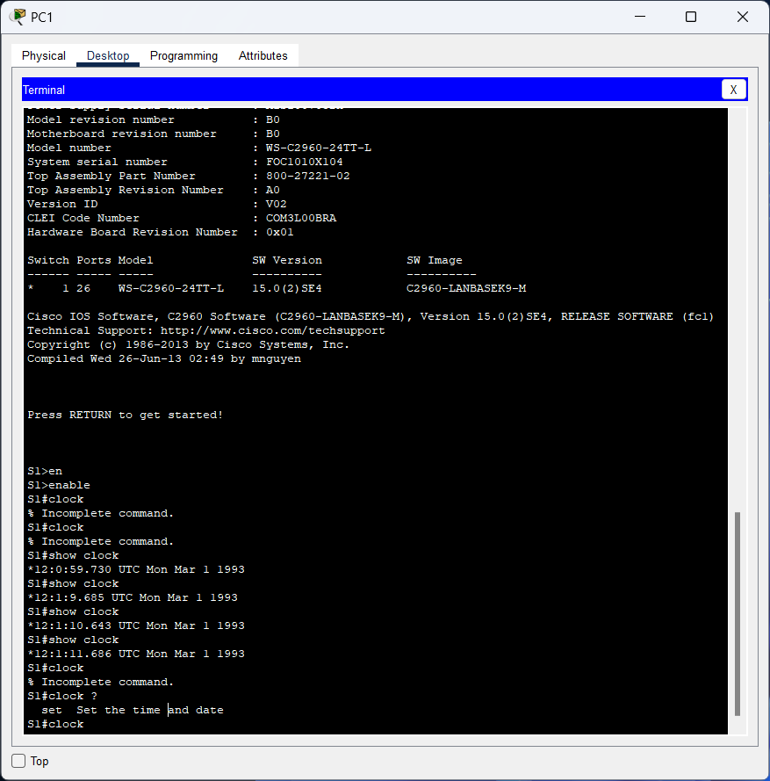

What information is displayed?

**Answer:**

The output of the executed command is to specify the desired time and date.

1. Set the clock using the **clock set** command. Proceed through the command one step at a time.

S1# **clock set ?**

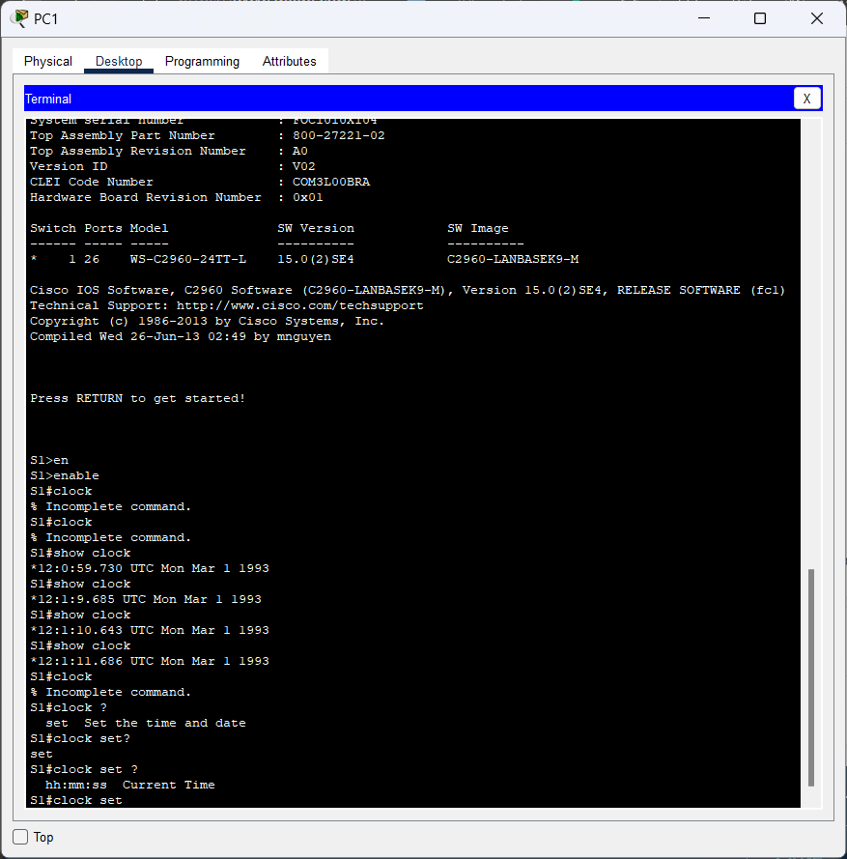

What information is being requested?

**Answer:**

The output of the executed command is to determine the hours, minutes, and seconds corresponding to the time in each region.

What would have been displayed if only the **clock set** command had been entered, and no request for help was made by using the question mark?

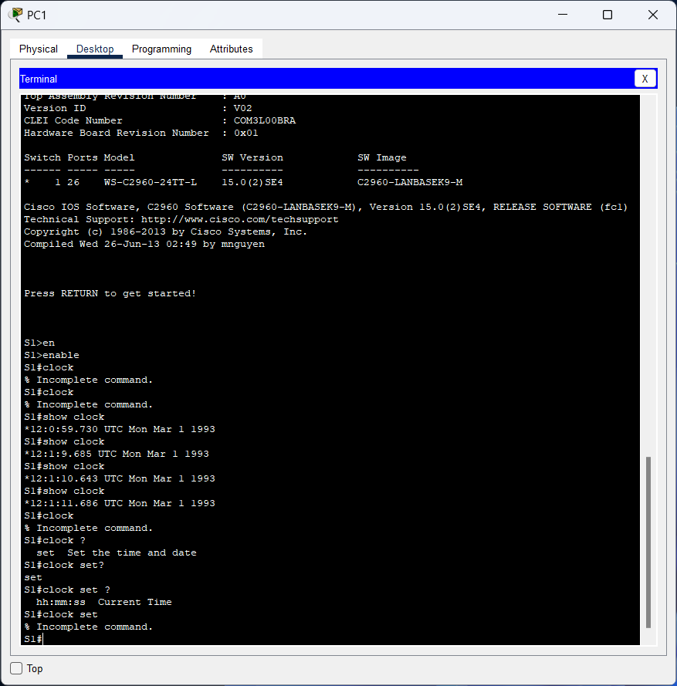

**Answer:**

The output of the command is a command that cannot be completed so the date and time cannot be changed.

1. Based on the information requested by issuing the **clock set ?** command, enter a time of 3:00 p.m. by using the 24-hour format of 15:00:00. Check to see if more parameters are needed.

S1# **clock set 15:00:00 ?**

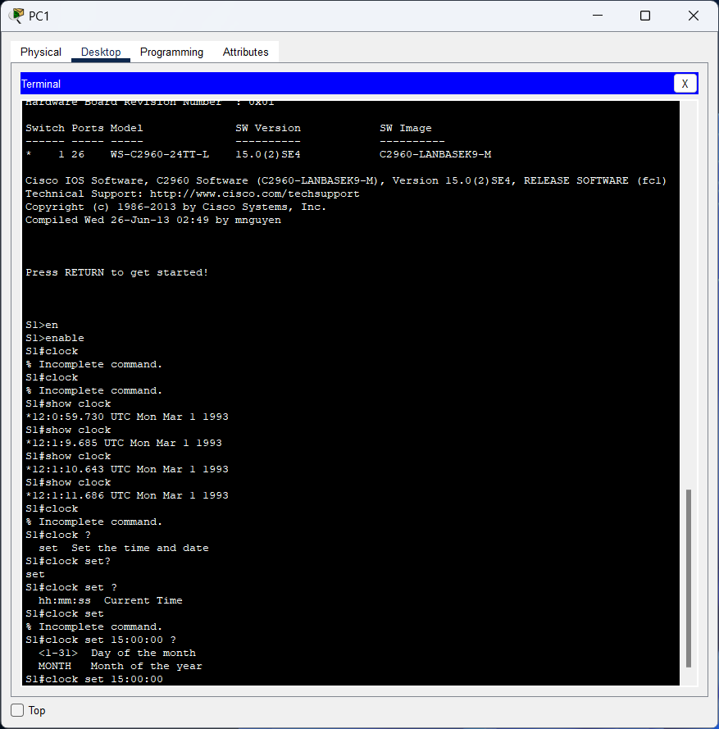

The output returns a request for more information:

<1-31> Day of the month

MONTH Month of the year

**Answer:**

The output of the command displayed in the image above is to specify the time, which is hours, minutes, and seconds. But what is missing is the date of the month and the month of the year.

1. Attempt to set the date to 01/31/2035 using the format requested. It may be necessary to request additional help using context-sensitive help to complete the process. When finished, issue the **show clock** command to display the clock setting. The resulting command output should display as:

S1# **show clock**

*15:0:4.869 UTC Tue Jan 31 2035

**Answer:**

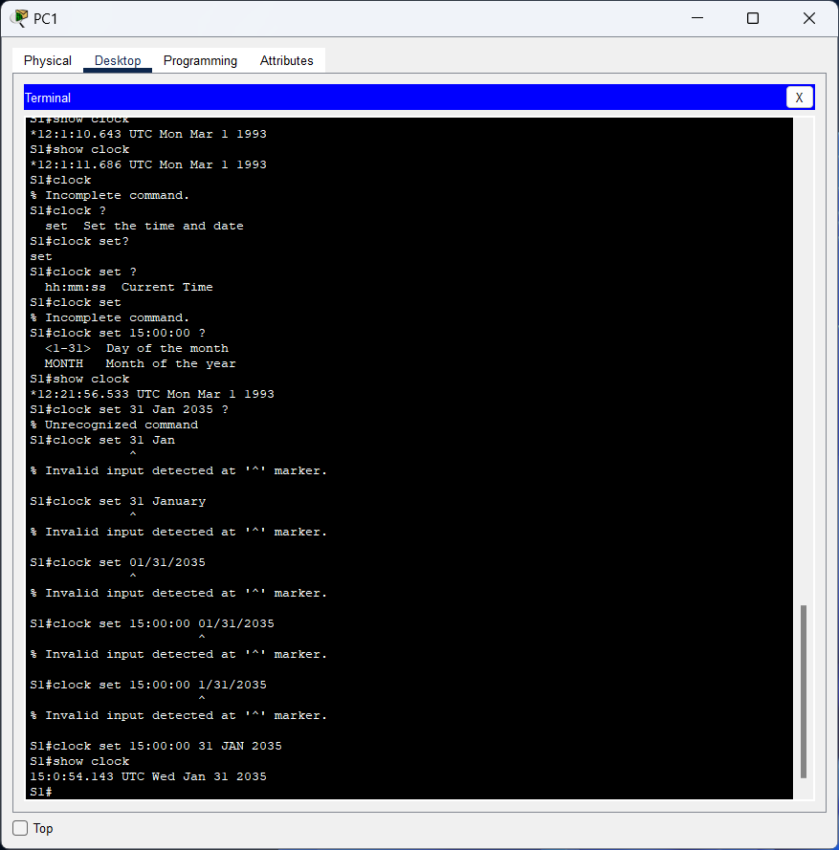

The output of the command in the image above is to first change the time and date, month, and year and type a command to display the changed time and date.

1. If you were not successful, try the following command to obtain the output above:

S1# **clock set 15:00:00 31 Jan 2035**

**Step 2: Explore additional command messages.**

1. The IOS provides various outputs for incorrect or incomplete commands. Continue to use the **clock** command to explore additional messages that may be encountered as you learn to use the IOS.
2. Issue the following commands and record the messages:

S1# **cl<tab>**

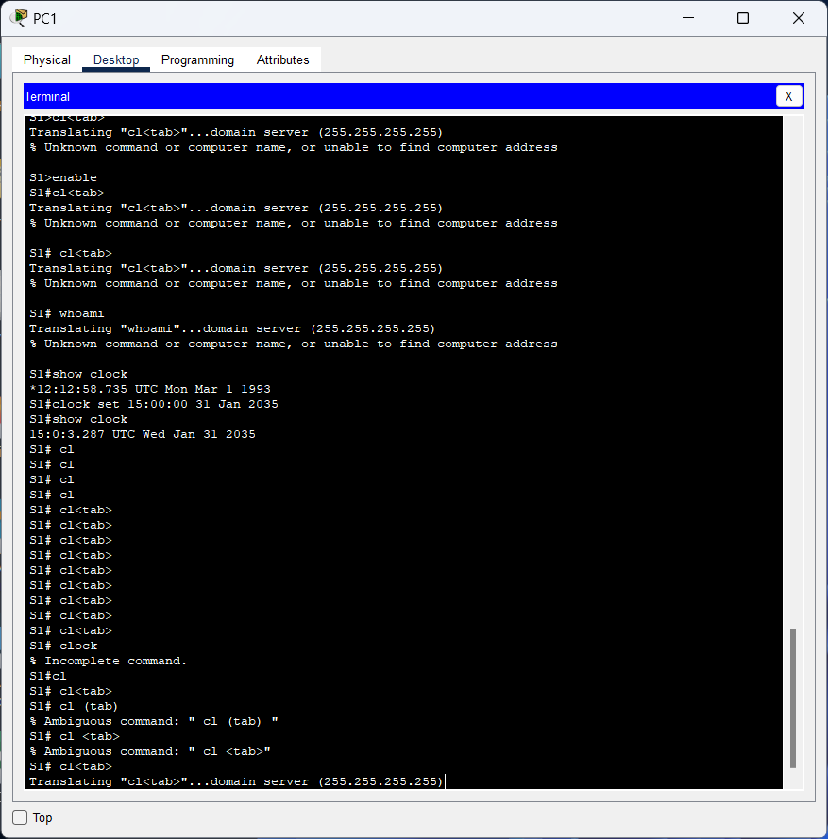

What information was returned?

**Answer:**

The output of the command used in the figure above is to translate the command to the domain server. I have also tried various ways to run it but the command is ambiguous so it cannot be run.

S1# **clock**

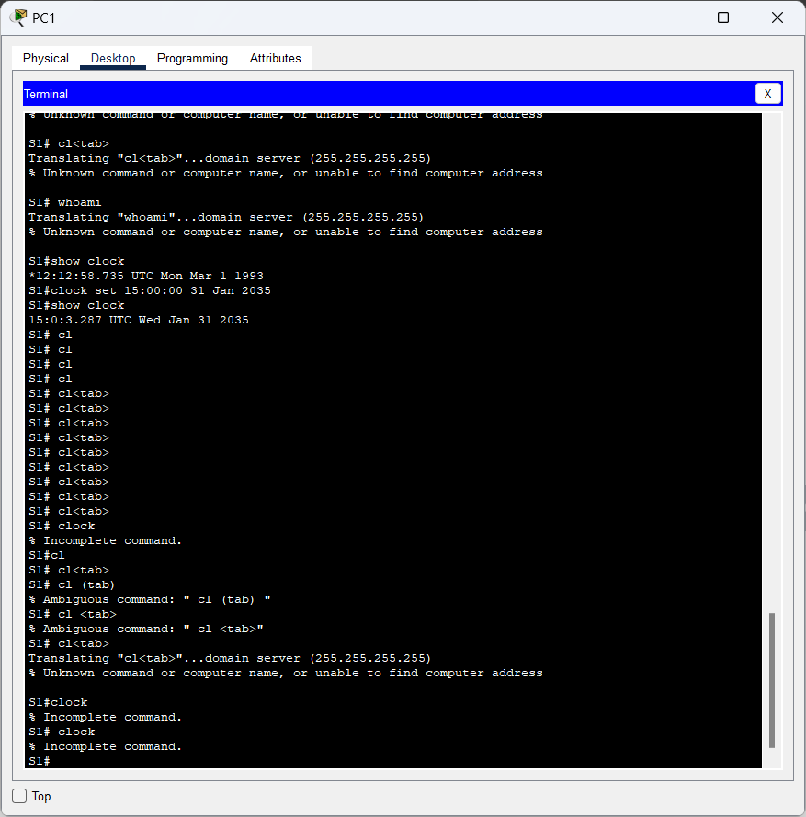

What information was returned?

**Answer:**

The output of the command executed in the figure above is a command that cannot be completed because the command on the end device does not understand the command.

S1# **clock set 25:00:00**

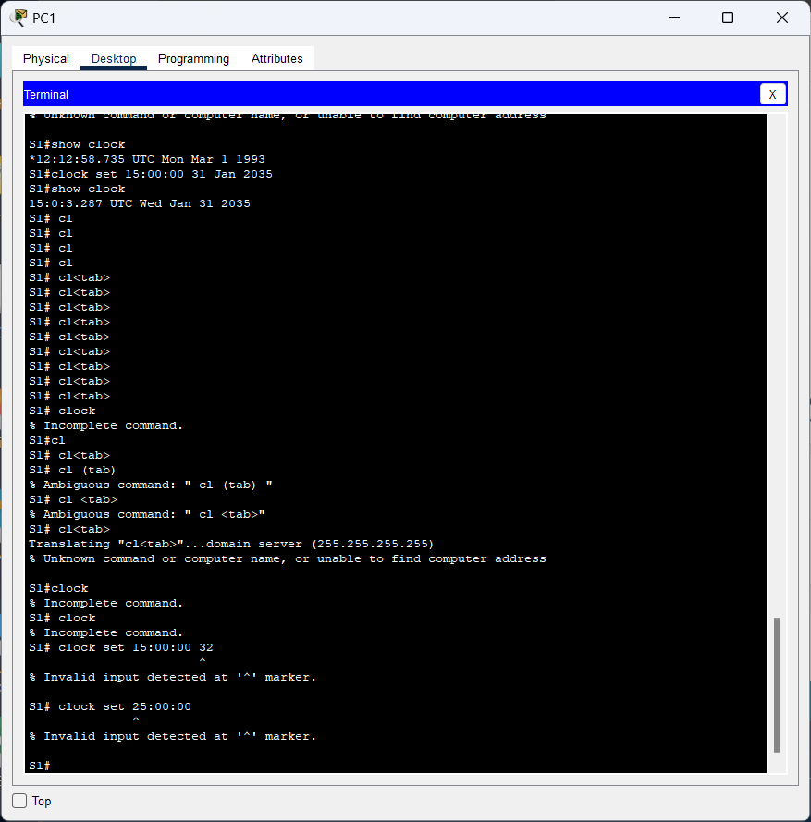

What information was returned?

**Answer:**

The output of the executed command is an invalid input where there is a ^ sign detected in the set part so that the command cannot be executed.

S1# **clock set 15:00:00 32**

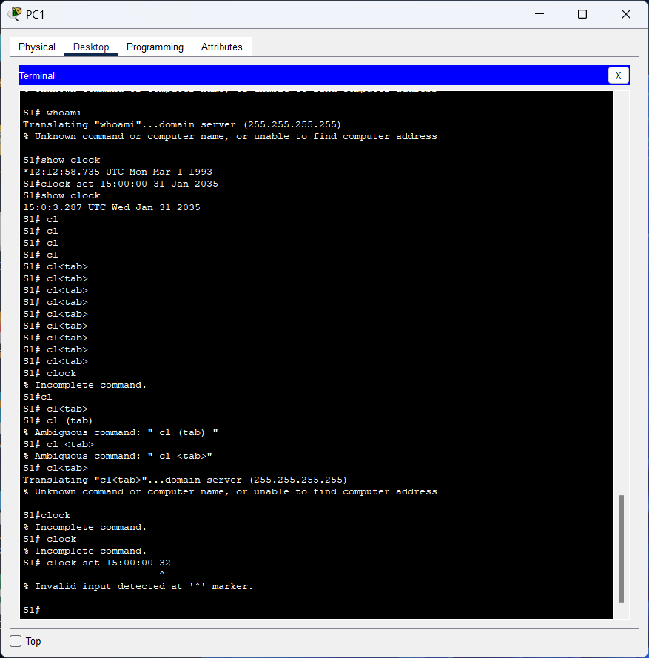What information was returned?

**Answer:**

The output of the executed command is an invalid input where there is a ^ sign detected in the second part of the time so it cannot be executed.